**Module – 5 [API Authentication & Security]**

1. **What is Middleware in express?**

* **Express** serves is use for a routing and Middleware framework is use for handling the different routing of the webpage and it works between the request and response cycle.
* It is executed after the server receives request and before the controller actions send the response.

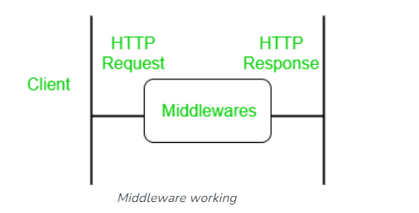

1. **What is json web token ?**

* JSON stands for Javascript Object Notation and is a text-based format for transmitting data accross web applications.
* A token is string of data that represent something else, we can call it is JSON object which is used to securly transfer information over the web(between two parties).
* It can be used for an authentication system and can also be used for information exchange.

1. **What is different between encryption and hashing?**

* Encryption is a reversible process, but hashing is not.
* Hashing is more secure for comparison with encryption.
* The main purpose of encryption is to secure the data by converting into an unreadable format.
* The main purpose of hashing is to check integrity of data.